Functional-nonfunctionnal requirements

Functional requirements:
  - Instant donation button. Under each donation case there would be button "donate", after pressing it you would be relocated to payment page.
  - Before relocated to payment page the CAPCHA should appear to verify whether user is a bot.
  - Payment. On the page of payment there should be interactive buttons, by clicking on them you can choose method of payment. There should be bank account, Google pay, apple pay, pay pal.
  - Design of a loading line for each donation case.

Non-functional requirements:
  - Main design. Montserrat font. Main colours white and blue.
  - Design of a donation page. Page with details and name of the organizations.
  - Money/financing. For each donation case it is used financial address of issuer.
  - Security. All countries are allowed to donate.

Requirements specification

External interface requirements

1.1 User Interface
The website should have user-friendly interfaces for:
- Donation submission and tracking;
- Observing the description of specific donation topic.

1.2 Hardware Interface
The system should be compatible with commonly used hardware, including PCs, tablets, and smartphones.

1.3 Software interface
The website may integrate with third-party payment gateways for donation processing.

1.4 Communication interface
The website should use secure communication protocols (HTTPS) to protect user data during transmission.

Functional requirements

2.1 Donation
Donors can select the purpose for their donation and specify the amount they wish to donate.
Payment processing should support various payment methods (credit card, PayPal, etc.).

Non-functional requirements

3.1 Performance
The website should load quickly and be responsive. It should handle a large number of concurrent users and donations. Response times for payment processing should be minimal.

3.2 Security
Regular security audits and updates should be conducted to protect against vulnerabilities.

3.3 Scalability
The system should be able to scale horizontally to accommodate increasing traffic and donations.

3.4 Usability
The website should follow best practices for user interface design. User feedback and surveys should be used to improve the user experience.

3.5 Accessibility
The website should comply with accessibility standards (e.g., WCAG) to ensure that it is usable by individuals with disabilities.

Requirements analysis
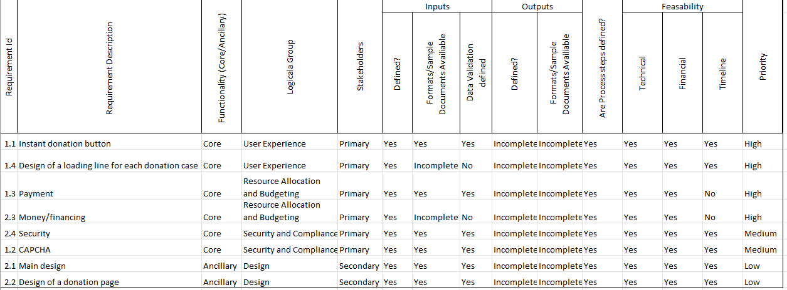

Validation and Approval
- Stakeholder Review Meetings: Schedule meetings with all key stakeholders, including clients, project managers, developers, and end-users, to discuss each requirement. The purpose is to ensure each requirement is well understood, realistic, and accurately aligned with project objectives.
- Requirement Validation: During the meetings, review each requirement to ensure it is complete, feasible, unambiguous, and in line with the project scope. Questions or feedback should be actively encouraged to clarify any ambiguities.
- Document Feedback and Adjust: Record any feedback from stakeholders, especially if there are concerns or misunderstandings regarding specific requirements. Adjustments may be needed to refine requirements based on this input.
- Obtain Formal Approval/Sign-Off: After addressing feedback, finalize the requirements document and seek formal sign-off from all stakeholders. This step signifies agreement on the scope and reduces the chance of disputes later on.

